Table of Contents

Argo energy analysis – from 06/03/2020 to 13/03/2020 2

1.0 Introduction 2

1.1 Energy 2

1.1.1 Node states 2

1.1.2 Energy reading per partition 2

1.1.3 Energy reading per feature 3

1.1.4 Classification per feature on a partition 4

1.2 Power 5

# Argo energy analysis – from 06/03/2020 to 13/03/2020

# 1.0 Introduction

We activated energy recording plugin in Slurm which is called the RAPL. RAPL measures energy for CPU and DRAM only. The period of measurement was approximately a week starting from 06/03/2020 to 13/03/2020. Argo is a heterogeneous cluster with nodes from different architectural family. When we configured the monitoring tool, the nodes needed to be restarted and this somehow gave us the variable to use to measure the time when this was running.

Command used to get the `scontrol show node -o `

# 1.1 Energy

## 1.1.1 Node states

|  |  |  |
| --- | --- | --- |
| **Node Name** | **State** | **Reasons** |
| Node103 | IDLE+DRAIN | Node crashes frequently |
| Node93 | IDLE+DRAIN | openib RETRY EXCEEDED ERROR |
| Node109 | IDLE+DRAIN | batch job complete failure |
| Node132 | IDLE+DRAIN | HD problems |
| Node133 | IDLE+DRAIN | Low RealMemory |
| Node134 | IDLE+DRAIN | Error |
| Serial02 | DOWN+POWER | ResumeTimeout reached |
| Westmere01 | IDLE+DRAIN+POWER | Low RealMemory |
|  |  |  |

**Table 1.0 Nodes with unusual reading**

## 1.1.2 Energy reading per partition

The table 1.1 shows the consumed Mega-joules(Mj) per partition and the lowest-Kilo-joules (kj). It can be noted that CMSP partition uses most of the energy followed by the long partition and GPU partition having the lowest energy. In addition to that GPU nodes have high Lowestkilojoules considering that they are just 2 nodes which is expected.

**Table 1.1 Energy statistics per partition**

**Fig 1.0 Energy consumption per partition**

According to figure 1.0, shows graphical presentation of consumed-joules and lowest-kilojoules of data that is in table 1.1.

## 1.1.3 Energy reading per feature

The energy consumed categorised by feature

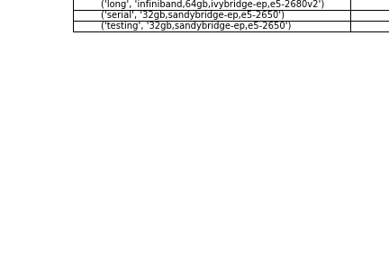

**Table 1.3 Energy statistics per partition**

## 1.1.4 Classification per feature on a partition

Feature distribution on the cluster

Distribution for nodes per partition

**CSMP energy**

**Long energy**

**GPU energy**

Estimation assuming that we use the recorded max energy for the type in line with maybe power cap

# 1.3 Power

Power Pie chat

Estimations

Maximum power

Consumed power

1.4 Conclusion and way forward